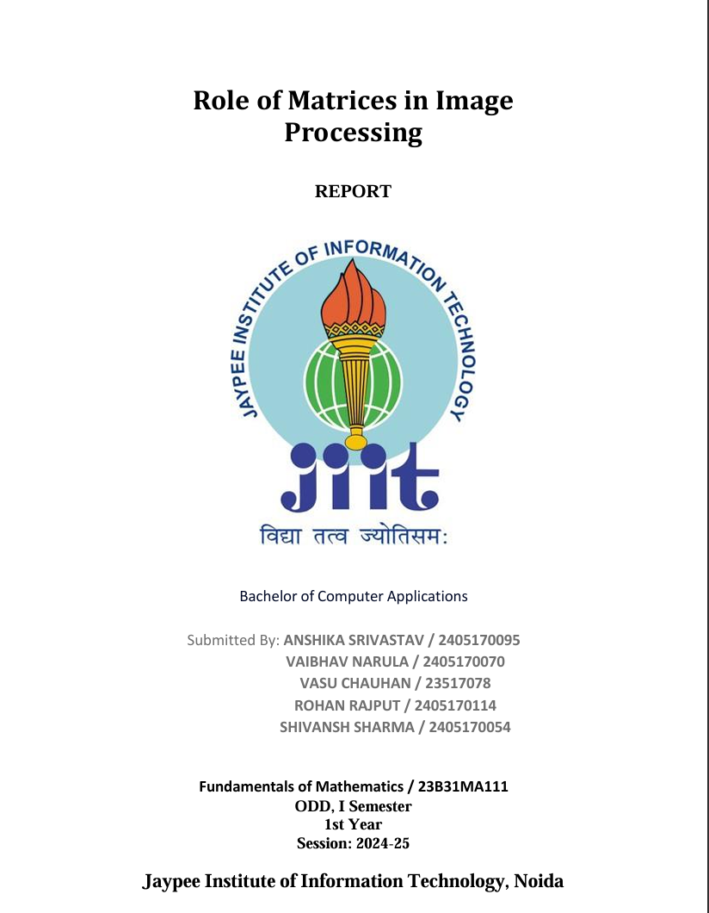



Table of Content

* Introduction
* Objective
* Motivation
* Methodology
* Results and Discussions
* Conclusion
* References

Introduction

Matrices play a fundamental role in image processing as they provide a mathematical framework for manipulating images. In digital image processing, an image is represented as a grid of pixels, where each pixel has a specific color or intensity value. This grid can be expressed as a matrix, with each cell (or element) in the matrix representing a pixel's intensity for grayscale images or separate matrices for red, green, and blue channels in color images.

Objectives

Matrices are used in various image processing operations, such as:

1. Image Transformation: Operations like translation, scaling, and rotation are matrix transformations that adjust an image's position, size, or orientation.

2. Filtering: Convolutional matrices (or kernels) are applied to images to perform operations like blurring, sharpening, and edge detection.

3. Compression: Techniques like the Discrete Cosine Transform (DCT), which is heavily used in JPEG compression, represent image data in terms of frequency, reducing storage needs.

4. Enhancement: Matrices enable contrast adjustments and noise reduction, enhancing image clarity and quality.

Motivation

The matrix-based approach allows for efficient and flexible manipulation of images, making it a powerful tool in computer vision, graphics, and multimedia applications.

Methodology

1. Setup: Install necessary libraries and software.

2. Image Collection: Prepare or collect images for processing.

3. Matrix Operations: Use matrices to apply filters, transformations, and other operations.

4. Image Processing Tasks: Implement tasks like edge detection, blurring, sharpening, or image segmentation using matrix operations.

5. Analysis and Visualization: Display results and analyze the effects of different matrix operations on images.

Results and Discussion

In a matrix, in which all elements are positive or equal to zero, we may present value 0 with black, and maximum positive value with white color; in this way, all positive matrix values will be presented as grayscale nuances (from black for zero, to white for maximum positive value).

Example 2.1: A matrix and its image:

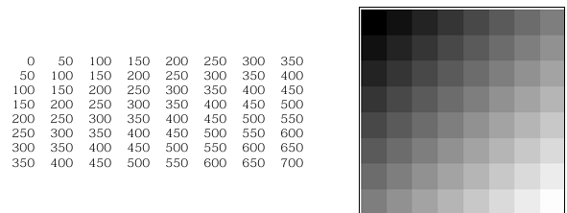

In this solution, matrix element values are scaled in order to be squeezed into interval [0, 255] – all matrix values are multiplied by factor (255/max. value) (in our example, this is 255/700). A matrix with all elements non-positive may be presented similarly, in nuances from black to yellow.

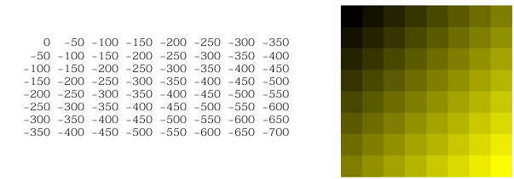

A matrix with positive and negative values will be presented with an image, in which positive values will be given in nuances from black to white, and negative – from black to yellow. Scaling may be done according to the biggest matrix elements magnitude. Example 2.3: The matrix

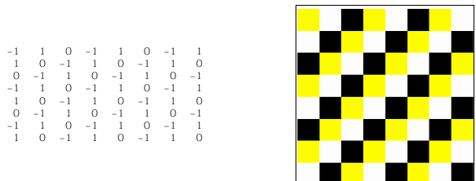

Example 2.4: In the next figure, two white Gaussian noise matrices2 may be seen. Matrix on the left is of considerably lower dimension comparing with that on the right, and its elements are presented "zoomed".



Conclusion

Here the proposed solution enables visualization of arbitrary matrices. The presented Result and Discussion are mainly related with linear transforms – DCT and Fourier, and blocked DCT (which is used in JPEG compression). This examples choice is made for the reader to understand better high dimension matrices, used in image processing. This solution may be helpful, not only to people that are engaged in image processing, but also to all engaged in (real or complex) high dimension matrices.

Reference

1. "Digital Image Processing" by Rafael C. Gonzalez and Richard E. Woods

2. "Linear Algebra and Its Applications" by Gilbert Strang

3. "Image Processing, Analysis, and Machine Vision" by Milan Sonka, Vaclav Hlavac, and Roger Boyle

4. "Fundamentals of Digital Image Processing" by Anil K. Jain

5. Khan Academy - Linear Algebra

6. "Applications of Linear Algebra in Image Processing" by J.C. Russ

THANK YOU